URL of the project (desktop and mobile): https://emilebedard.github.io/cart263/Projects/project2/interactive_bike_garage_ii/

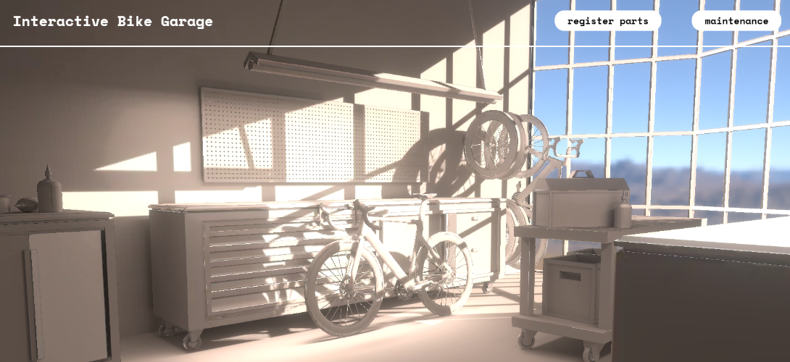

Main landing page

The main atmosphere of the web experience was the whole idea of the second project: offer an immersive 3D modern scene of a bicycle workshop. I modeled everything except for the bike and decided on the layout and composition of the scene based on my own preferences. I would like to imagine this space as my own future workshop.

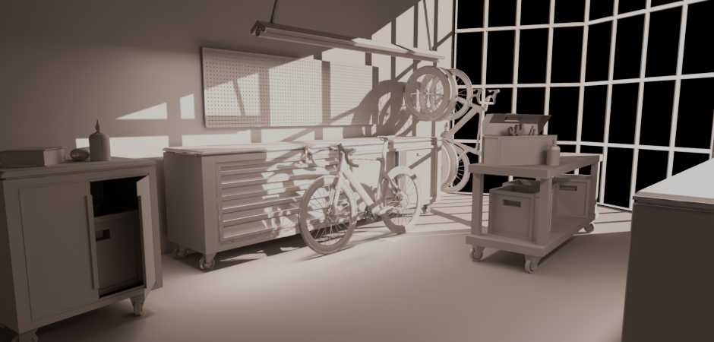

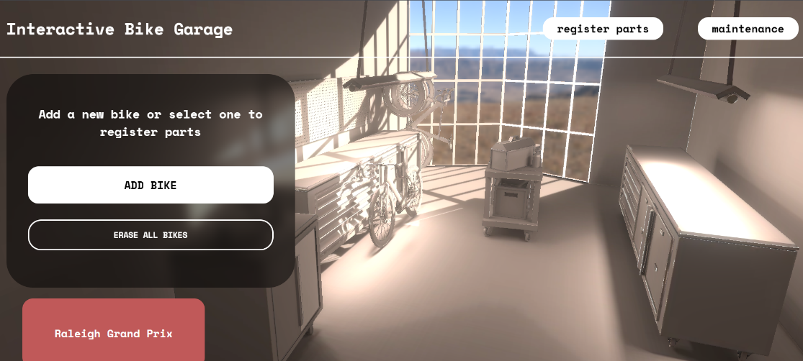

Layout and HTML hierarchy

My next challenge was to keep as much as possible from my previous hmtl/css layout and maximize my time and energy on the 3D with Three.js. It was not was and I feal still not completely sure about the styling but integrating the 3D canvas seamlessly was not easy. For the next version, I will start from scratch and build on top of the canvas to really make a new styling and UI interface that feels much more integrated and cohesive.

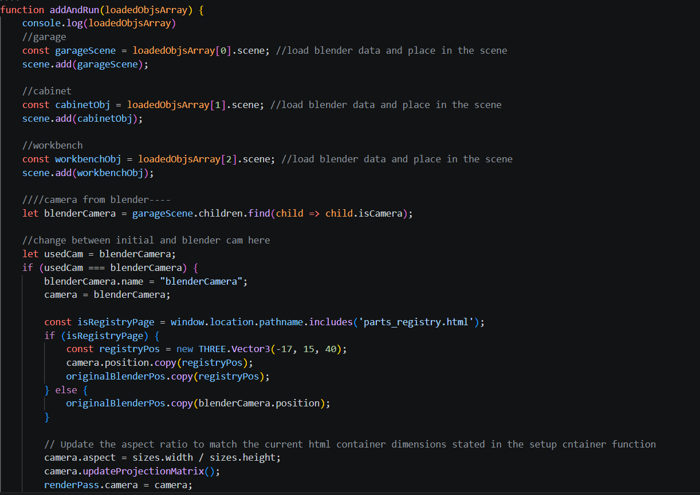

Importing and integrating GLTF in THREE.JS

Importing gltf and retrieving data, animation, scenes, lights and cameras was very tricky.

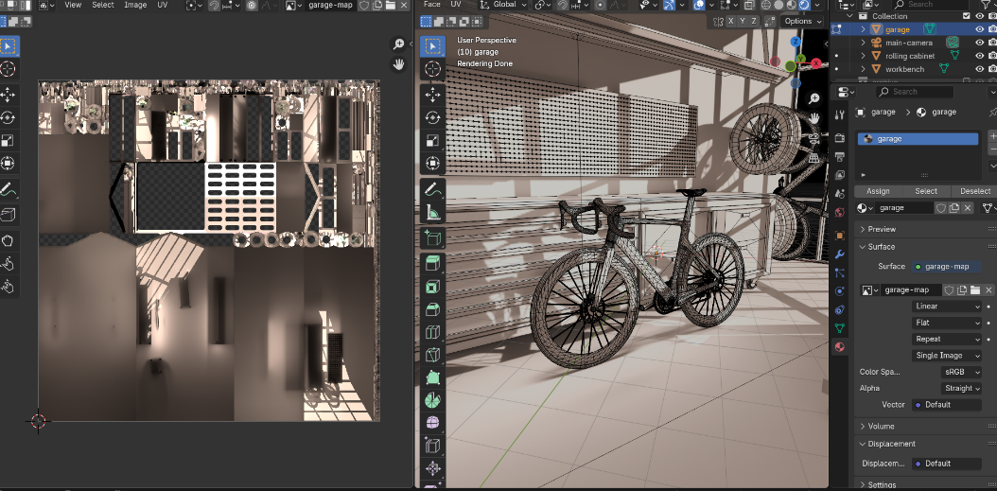

Layout and HTML hierarchy

My next challenge was to keep as much as possible from my previous hmtl/css layout and maximize my time and energy on the 3D with Three.js. It was not wasy and I feal still not completely sure about the styling but integrating the 3D canvas seamlessly was not easy. For the next version, I will start from scratch and build on top of the canvas to really make a new styling and UI interface that feels much more integrated and cohesive.

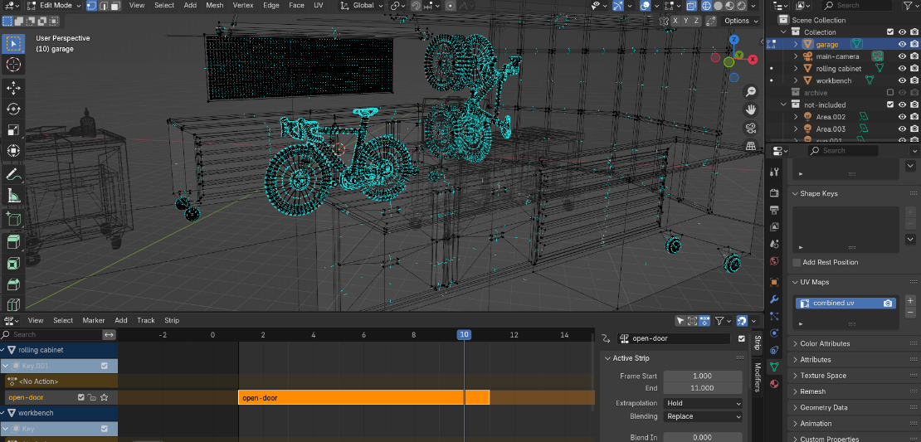

Layout and HTML hierarchy

My next challenge was to keep as much as possible from my previous hmtl/css layout and maximize my time and energy on the 3D with Three.js. It was not wasy and I feal still not completely sure about the styling but integrating the 3D canvas seamlessly was not easy. For the next version, I will start from scratch and build on top of the canvas to really make a new styling and UI interface that feels much more integrated and cohesive.

